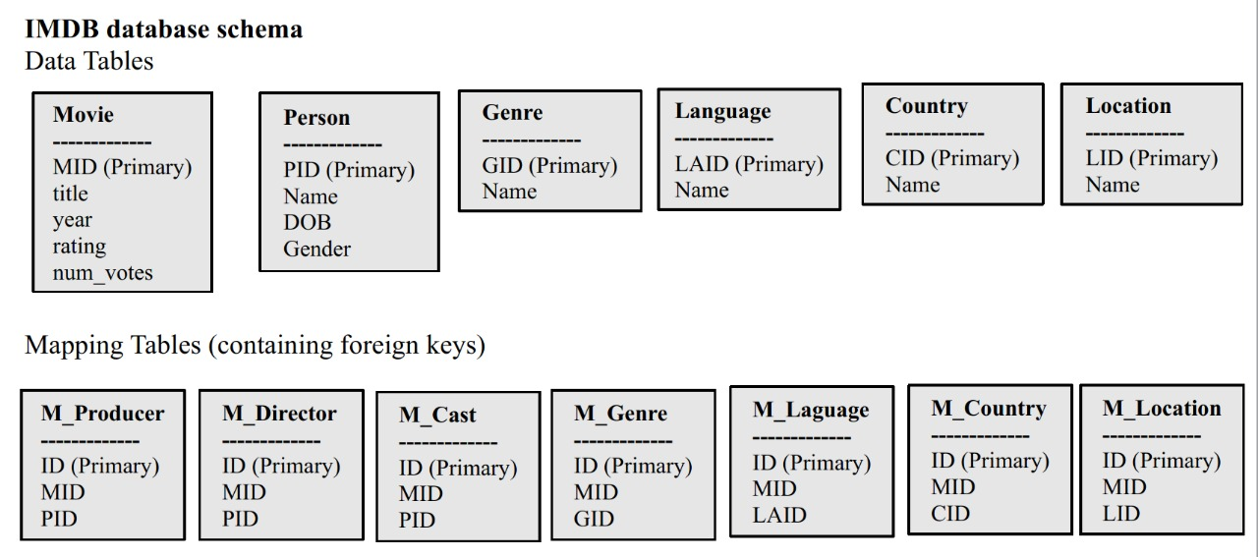

**IMDB database schema Data Tables**

**Movie**

**Genre**

**Language**

**Country**

**Person**

**Location**

MID (Primary) title year

GID (Primary) Name

LAID (Primary) Name

CID (Primary) Name

LID (Primary) Name

PID (Primary) Name DOB Gender

rating

num_votes

Mapping Tables (containing foreign keys)

**M Producer**

**M Director**

**M_Cast**

**M_Genre**

**M_Laguage**

**M_Country**

**M Location**

ID (Primary) MID PID

ID (Primary) MID PID

ID (Primary) MID PID

ID (Primary) MID GID

ID (Primary) MID LAID

ID (Primary) MID CID

ID (Primary) MID LID